

UNIVERSITY OF BUEA
FACULTY OF ENGINEERING AND TECHNOLOGY
DEPARTMENT OF COMPUTER ENGINEERING
CEF440: INTERNET PROGRAMMING AND MOBILE PROGRAMMING
PROJECT TITLE: DESIGN AND IMPLEMENTATION OF AN ADAPTIVE E-LEARNING PLATFORM BASED ON QUALITY OF EXPERIENCE FOR INCLUSIVE ONLINE EDUCATION IN LOW – RESOURCE SETTINGS.
TASK 6
Group 15 Report
COURSE INSTRUCTOR: Dr Nkemeni Valery
NAME | MATRICULE
NJINYA NGECHA RYAN BROWN | FE23A116
KARL JONAS WENGE ACHA | FE23A072
BRIANNA TEBESICK TSAMO | FE23A028
KELSEY NJOCK-AWOH NJOCK OBEN | FE23A073

15th June 6, 2026

Table of Contents – Task 6 Report
- Introduction .................................................. 1
  - Purpose of database design
  - Backend and frontend integration
- Data Elements .............................................. 2
2.1 User Data Elements ....................................... 2
2.2 Course Data Elements .................................... 3
2.3 Lesson Data Elements .................................... 3
2.4 Enrollment Data Elements .............................. 4
2.5 Progress Data Elements ................................ 4
2.6 Quiz Data Elements ....................................... 5
2.7 Question Data Elements ................................ 5
2.8 Quiz Result Data Elements ............................ 6
2.9 Parent-Child Data Elements .......................... 6
- Conceptual Design ......................................... 7
3.1 Institutional Layer ......................................... 7
3.2 User Layer ..................................................... 7
3.3 Learning Process Layer .................................. 8
3.4 Assessment & Progress Layer ....................... 8
3.5 Quality & Reporting Layer ............................. 9
3.6 Key Relationships .......................................... 9
- ER Diagram .................................................... 10
4.1 Institutional Entities ....................................... 10
4.2 User Entities .................................................. 11
4.3 Learning Process Entities .............................. 11
4.4 Assessment & Progress Entities ................... 12
4.5 Quality & Monitoring Entities ....................... 13
4.6 Key Relationships .......................................... 13
- Database Implementation ............................... 14
5.1 Technology Used ............................................ 14
5.2 Database Creation ........................................... 14
5.3 Prisma Schema Implementation .................... 15
5.4 Database Constraints ..................................... 15
5.5 Database Migration ......................................... 16
5.6 Database Seeding ............................................ 16
- Backend Implementation ................................ 17
6.1 Technology Used ............................................ 17
6.2 Folder Structure .............................................. 17
6.3 Express Server Setup ...................................... 18
6.4 Express App Setup ........................................... 18
6.5 Authentication Implementation ..................... 19
6.6 Authentication Routes .................................... 19
6.7 Course Routes ................................................ 20
6.8 Lesson Routes ................................................ 20
6.9 Quiz Routes .................................................... 21
6.10 Dashboard Route .......................................... 21
- Connecting Database to Backend .................. 22
7.1 Environment Variables .................................... 22
7.2 Prisma Client Connections ............................. 22
7.3 Example: Fetching Courses ............................ 23
7.4 Example: Enrolling a Learner ........................ 23
- Testing ............................................................ 24
8.1 Backend Health Test ....................................... 24
8.2 Login Test ....................................................... 24
8.3 Courses Test ................................................... 25
8.4 Dashboard Test .............................................. 25
- Challenges Encountered ................................ 26
9.1 PostgreSQL Installation .................................. 26
9.2 Prisma Configuration ....................................... 26
9.3 Authentication Header .................................... 27
- Conclusion .................................................... 28

Task 6: Database Design and Implementation
1. Introduction
This task focuses on the database design and backend implementation of the Learn Bridge adaptive e-learning platform. The purpose of the database is to store and manage the core data required by the system, including users, courses, lessons, enrollments, learner progress, quizzes, quiz questions, quiz results, and parent-child relationships.
The database is an essential part of the system because the frontend alone cannot permanently store real application data. The frontend displays the user interface, while the backend receives requests from the frontend, processes them, communicates with the database, and sends responses back to the frontend. Therefore, the database, backend, and frontend work together to provide a complete functional system.
For this implementation, the system uses:
PostgreSQL as the relational database management system.
Prisma ORM as the database access layer.
Node.js and Express.js for backend API development.
JWT authentication for secure user login and protected routes.
bcryptjs for password hashing.
Next.js frontend connected to the backend through API requests.
The database design follows a relational model because Learn Bridge contains entities that are strongly related to each other. For example, a learner can enroll in many courses, a course can contain many lessons, a quiz can contain many questions, and a learner can submit many quiz results.
2. Data Elements
The data elements represent the main information stored and processed by the Learn Bridge system. These elements were identified based on the system requirements and the main user roles: learner, instructor, parent, and administrator.
2.1 User Data Elements
The User entity stores all registered users of the platform. A user may be a learner, instructor, parent, or administrator.
Data Element | Description | Example
User ID | Unique identifier for each user | Cm123abc
Name | Full name of the user | Student User
Email | User’s email address used for the login | learner@learnbridge.com
Password | Hashed password stored securely | $2a$12…
Role | Defines the type of user | LEARNER, INSTRUCTOR, PARENT, ADMIN
Avatar URL | Optional profile image or avatar | https://...
Created At | Date the account was created | 2026-06-12
Updated At | Date the account was last updated | 2026-06-12

The user role is important because it determines which part of the system the user can access. For example, learners can view courses and track progress, instructors can create courses, parents can monitor child progress, and administrators can manage the system.
2.2 Course Data Elements
The Course entity stores details about courses available on Learn Bridge.
Data Element | Description | Example
Course ID | Unique identifier for each course | Course001
Title | Course name | Introduction to mathematics
Description | Course explanation | A beginner mathematics course
Category | Course subject area | Mathematics
Level | Difficulty Level | BEGINNER
Image URL | Optional Course image | Math-course.png
Price | Course Price | 0
Published Status | Whether the course is available | True
Instructor ID | User ID of the instructor | Instructor001
Created At | Course creation date | 2026-06-12
Updated At | Last updated date | 2026-06-12

Courses are connected to instructors, lessons, quizzes, enrollments, and learner progress.
2.3 Lesson Data Elements
The Lesson entity stores learning content inside a course.
Data Element | Description | Example
Lesson ID | Unique identifier for each lesson | lesson001
Title | Lesson Title | Numbers and Operations
Content | Lesson text content | This lesson introduces basic numbers…
Video URL | Optional video lesson link | https://...
Order | Lesson sequence inside a course | 1
Duration | Estimated Lesson duration in minutes | 20
Course ID | Course the Lesson belongs to | Course001
Created At | Lesson creation date | 2026-06-12
Updated At | Last update date | 2026-06-12

The lesson order is important because it allows the course content to be displayed in the correct sequence.
2.4 Enrollment Data Elements
The Enrollment entity connects learners to courses. It shows which learner has joined which course.
Data Element | Description | Example
Enrollment ID | Unique enrollment identifier | Enroll001
Learner ID | User ID of the learner | Learner001
Course ID | Course ID of the enrolled course | Course001
Enrolled At | Date of enrollment | 2026-06-12

A learner can enroll in many courses, and a course can have many learners. This creates a many-to-many relationship between learners and courses, handled through the Enrollment table.
2.5 Progress Data Elements
The Progress entity tracks lesson completion by learners.
Data Element | Description | Example
Progress ID | Unique progress record | Progress001
Learner ID | User ID of the learner | Learner001
Course ID | Course being studied | Course001
Lesson ID | Completed lesson | Lesson001
Is Completed | Completion status | True
Completed At | Completion date | 2026-06-12

This table is important because it allows the system to calculate dashboard progress, completed lessons, and overall learning percentage.
2.6 Quiz Data Elements
The Quiz entity stores quizzes attached to courses.
Data Element | Description | Example
Quiz ID | Unique quiz identifier | Quiz001
Title | Quiz title | Basics Mathematics Quiz
Description | Quiz explanation | Short quiz for mathematics
Course ID | Course the quiz belongs | Course001
Created At | Quiz creation | 2026-12-06
Updated At | Last update date | 2026-06-12

A course can have many quizzes.
2.7 Question Data Elements
The Question entity stores quiz questions.
Data Element | Description | Example
Question ID | Unique question identifier | Question001
Text | Question text | What is 2 + 2?
Options | Available answer choices | [“2”, “3”, “4”, “5”]
Correct Answer | Correct Option | 4
Points | Marks assigned to the question | 1
Quiz ID | Quiz the question belongs to | Quiz001

The options field is stored as JSON because each question can have a flexible list of choices.
2.8 Quiz Result Data Elements
Data Element | Description | Example
Result ID | Unique result identifier | Result001
Learner ID | User ID of the learner | Learner001
Quiz ID | Quiz Submitted | Quiz001
Score | Marks obtained | 2
Total Points | Maximum possible marks | 2
Answers | Learner’s submitted answers | { “q1”: “4” }
Submitted At | Submission date | 2026-06-12

This table supports performance tracking and learner assessment.
2.9 Parent-Child Data Elements
The Parent Child entity links a parent account to a child learner account.
Data Element | Description | Example
Parent Child ID | Unique relationship identifier | Pc001
Parent ID | User ID of the parent | parent001
Child ID | User ID of the learner/child | learner001

This relationship allows parents to monitor the learning progress of their children.
3. Conceptual Design
The conceptual data design defines the high-level structure of the system. It identifies the main entities, their roles, and relationships without going into implementation details like attributes or keys. Its goal is to ensure that all stakeholder needs (learners, instructors, parents, administrators, and the institution) are represented before moving to logical and physical design.
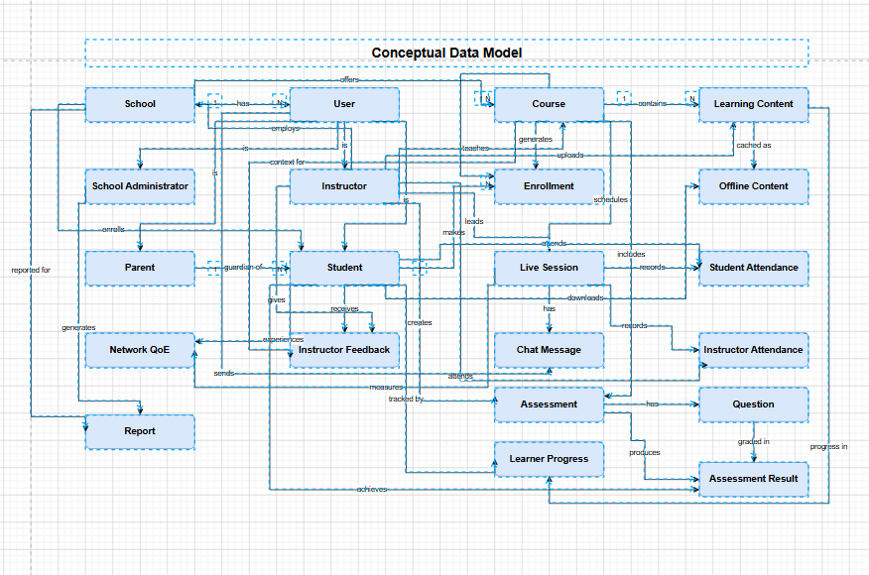

3.1 Institutional Layer
- School: The root entity providing the educational environment.
- School Administrator: Manages attendance, learner progress, and reporting.
- Parent: Connected to reports and learner progress for monitoring.
This layer ensures oversight, accountability, and supervision.

3.2 User Layer
- User: Generalized entity specialized into Student and Instructor.
- Student: Enrolls in courses, attends live sessions, interacts via chat, and generates assessment results.
- Instructor: Teaches courses, uploads content, manages live sessions, and provides feedback.
This layer supports role-based access control and separates responsibilities clearly.

3.3 Learning Process Layer
- Course: Central entity linking enrollment, content, and assessments.
- Enrollment: Connects students to courses.
- Learning Content: Multimedia materials (video, audio, text).
- Offline Content: Downloadable lessons for low-resource settings.
- Live Session: Real-time teaching and interaction, linked to chat messages.
This layer implements requirements like multimedia support, offline access, and live interaction.

3.4 Assessment & Progress Layer
- Assessment: Contains questions and produces results.
- Assessment Result: Linked to learner progress.
- Learner Progress: Aggregates assessment, attendance, and activity data.
- Instructor Feedback: Qualitative evaluation of learners.
- Student Attendance / Instructor Attendance: Tracks participation in sessions.
This layer supports quizzes, attendance tracking, and parental monitoring dashboards.

3.5 Quality & Reporting Layer
- Network QoE (Quality of Experience): Monitors connectivity and performance.
- Report: Generated for parents and administrators, includes attendance, progress, and performance analytics.
This layer ensures adaptive delivery under poor network conditions and provides institutional reporting.

3.6 Key Relationships
- School → employs → Administrator / Instructor
- Student → enrolls → Course
- Instructor → teaches → Course
- Course → includes → Learning Content / Offline Content / Assessments
- Live Session → records → Attendance / Chat Messages
- Assessment → produces → Assessment Result → tracks → Learner Progress
- Learner Progress → generates → Report → accessed by Parent / Administrator
- Network QoE → influences → Report & Learning Experience
4. ER Diagram
The ER diagram defines the database schema for the adaptive e-learning platform. Unlike the conceptual design, this logical model specifies tables, attributes, keys, and relationships. It ensures that all stakeholder requirements (learners, instructors, parents, administrators, and system monitoring) are supported by a structured, relational database.
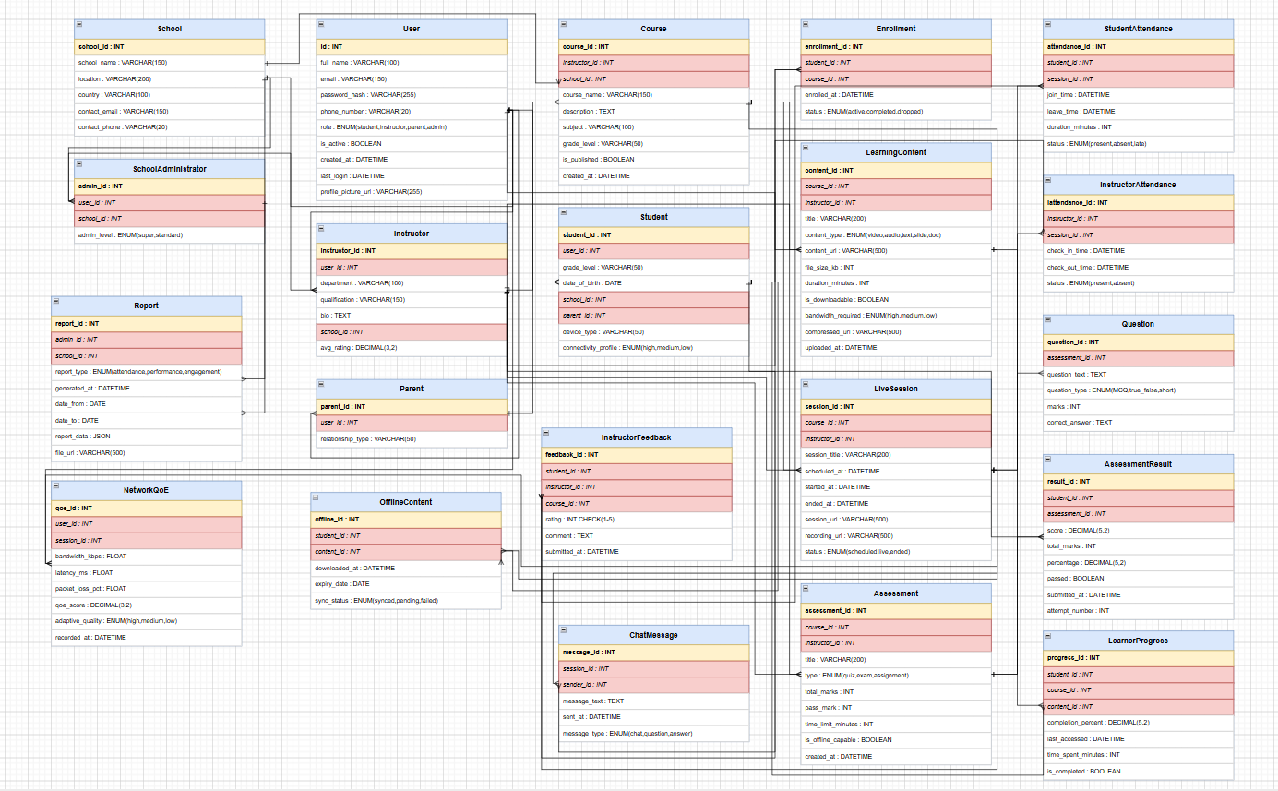

4.1 Institutional Entities
- School
Attributes: SchoolID (PK), Name, Location.
Relationships: Employs School Administrator and Instructor.
- School Administrator
Attributes: AdminID (PK), SchoolID (FK), Name, Email.
Manages reports, attendance, and learner progress.
- Report
  - Attributes: ReportID (PK), AdminID (FK), StudentID (FK), ProgressID (FK).
  - Provides performance and attendance summaries.
This layer ensures institutional oversight and accountability.

4.2 User Entities
- User (generalized table)
Attributes: UserID (PK), Name, Email, Role.
Specialized into Student and Instructor.
- Student
Attributes: StudentID (PK, FK from User), EnrollmentID (FK).
Linked to courses, assessments, attendance, and progress.
- Instructor
Attributes: InstructorID (PK, FK from User), SchoolID (FK).
Linked to courses, live sessions, and feedback.
Supports role-based access control and separates learner vs. instructor responsibilities.

4.3 Learning Process Entities
- Course
Attributes: CourseID (PK), Title, InstructorID (FK).
Linked to Enrollment, Learning Content, and Assessment.
- Enrollment
Attributes: EnrollmentID (PK), CourseID (FK), and StudentID (FK).
Connects students to courses.
- Learning Content
Attributes: ContentID (PK), CourseID (FK), and Type (video/audio/text).
- Offline Content
Attributes: OfflineID (PK), CourseID (FK), File Path.
- Live Session
Attributes: SessionID (PK), CourseID (FK), InstructorID (FK), DateTime.
Linked to Chat Message and Attendance.
- Chat Message
Attributes: MessageID (PK), SessionID (FK), SenderID (FK), Content.
Implements requirements for multimedia content, offline access, live interaction, and chat features.

4.4 Assessment & Progress Entities
- Assessment
Attributes: AssessmentID (PK), CourseID (FK), Type.
Contains Questions.
- Question
Attributes: QuestionID (PK), AssessmentID (FK), Text.
- Answer Result
Attributes: ResultID (PK), QuestionID (FK), StudentID (FK), Score.
- Learning Progress
Attributes: ProgressID (PK), StudentID (FK), CourseID (FK), Completion Rate.
- Instructor Feedback
Attributes: FeedbackID (PK), InstructorID (FK), StudentID (FK), Comments.
- Student Attendance / Instructor Attendance
Attributes: AttendanceID (PK), SessionID (FK), UserID (FK), Status.
Supports quizzes, assessments, attendance tracking, and progress monitoring.

4.5 Quality & Monitoring Entities
- NetworkQoC (Quality of Connection/Experience)
Attributes: QoCID (PK), SessionID (FK), Bandwidth, Latency, PacketLoss.
Ensures adaptive delivery under poor network conditions.
Implements QoE-based adaptation for low-resource environments.

4.6 Key Relationships
- School → School Administrator / Instructor
- Instructor → teaches → Course
- Student → enrolls → Course
- Course → includes → Learning Content / Offline Content / Assessment
- Assessment → contains → Question → produces → Answer Result
- Answer Result → updates → Learning Progress → generates → Report
- Live Session → records → Attendance / Chat Message
- NetworkQoC → monitors → Live Session performance
This ER diagram provides a complete logical schema for the adaptive e-learning platform. It translates the conceptual design into tables, attributes, and relationships, ensuring that all functional and non-functional requirements are supported. It is ready to be extended into a physical database implementation (e.g., PostgreSQL).
5. Database Implementation
5.1 Database Technology Used
The database was implemented using PostgreSQL. PostgreSQL was selected because it is a reliable relational database management system that supports structured data, relationships, constraints, and transactions.
The system also uses Prisma ORM to simplify database operations. Prisma allows the backend to communicate with the database using JavaScript/TypeScript code instead of writing raw SQL queries manually for every operation.
5.2 Database Creation
A database named learnbridge was created in PostgreSQL. The backend connects to this database using a connection string stored in the backend .env file.
Example database connection string:
This connection string contains:
Database provider: PostgreSQL
Username: postgres
Password: the PostgreSQL password
Host: localhost
Port: 5432
Database name: learnbridge
Schema: public
5.3 Prisma Schema Implementation
The Prisma schema was used to define the structure of the database. Each Prisma model represents a database table.
Example:
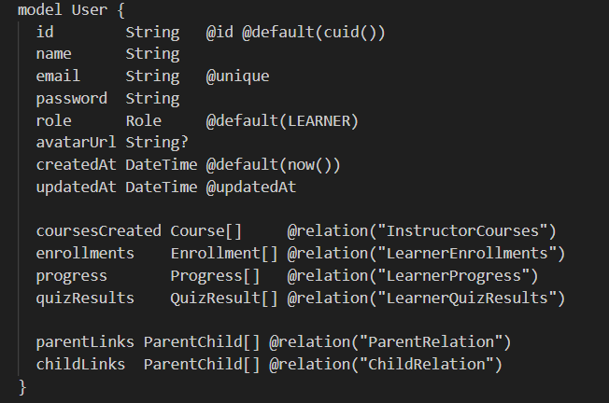
This model creates a User table with fields such as ID, name, email, password, role, and timestamps.
5.4 Important Database Constraints
Several constraints were included to protect the integrity of the database.
Unique Email Constraint
Each user must have a unique email address:
email String @unique
This prevents two users from registering with the same email.
Unique Enrollment Constraint
A learner should not enroll in the same course more than once:
@@unique([learnerId, courseId])
This ensures that duplicate enrollments are prevented.
Unique Lesson Progress Constraint
A learner should have only one progress record per lesson:
@@unique ([learnerId, lessonId])
This prevents repeated progress records for the same lesson.
Cascade Delete
Some relationships use cascade delete. For example, when a course is deleted, related lessons can also be deleted:
course Course @relation (fields: [courseId], references: [id], onDelete: Cascade)
This helps maintain database consistency.
5.5 Database Migration
After defining the Prisma schema, the database tables were created using Prisma migration.
Command used:
This command reads the Prisma schema and creates the corresponding tables in the PostgreSQL database.
The generated tables include:
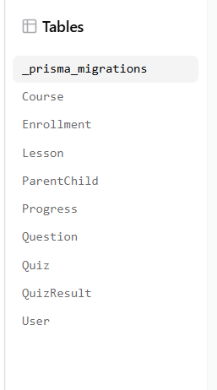
5.6 Database Seeding
A seed file was created to insert initial test data into the database.
The seed data included:
A learner account
An instructor account
A sample course
Sample lessons
A sample quiz
Sample quiz questions
A sample enrollment
Example test accounts:
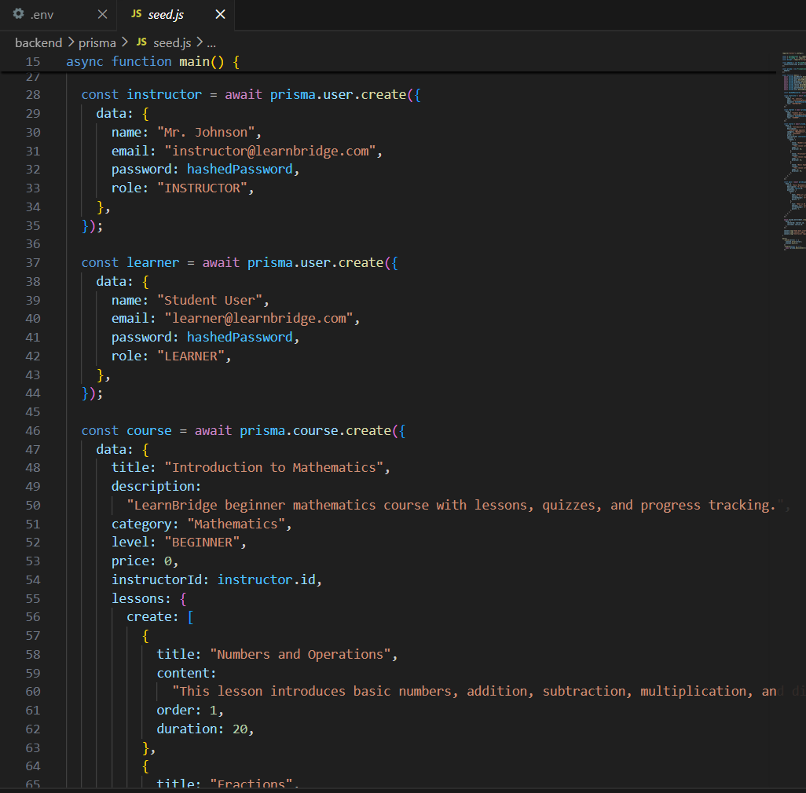
The seed file was executed using:
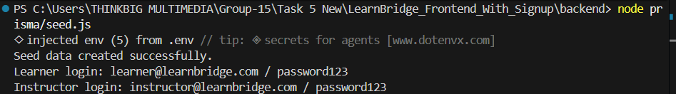
Database seeding helped test the system immediately without manually inserting records one by one.
6. Backend Implementation
6.1 Backend Technology Used
The backend was implemented using Node.js and Express.js. Express was used to create API routes that allow the frontend to communicate with the database.
The backend is responsible for:
Receiving requests from the frontend
Authenticating users
Registering new users
Logging in existing users
Reading courses from the database
Enrolling learners in courses
Tracking lesson progress
Submitting quizzes
Returning dashboard data
6.2 Backend Folder Structure
The backend was organized into separate folders for maintainability.
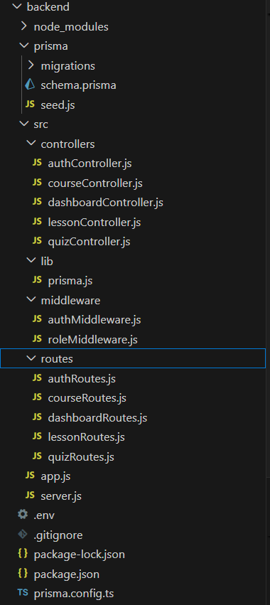
This structure separates responsibilities clearly:
routes define API endpoints.
controllers contain business logic.
middleware handles authentication and authorization.
lib/prisma.js manages the database connection.
6.3 Express Server Setup
The server starts from server.js.
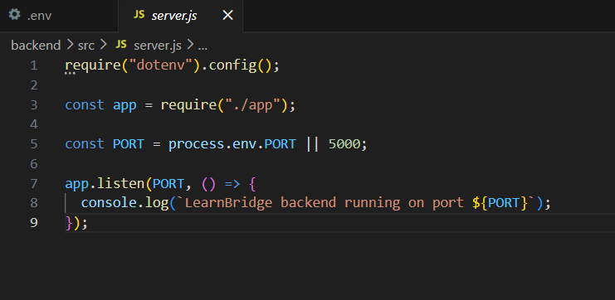
The backend runs on:
http://localhost:5000
6.4 Express App Setup
The main app file connects middleware and routes.
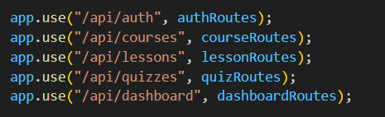
This means the frontend can call routes such as:
/api/auth/login
/api/courses
/api/dashboard/learner
6.5 Authentication Implementation
Authentication was implemented using:
bcryptjs
JSON Web Token
When a user registers, the password is hashed before being saved to the database.
Example:
const hashedPassword = await bcrypt.hash (password, 12);
When a user logs in, the backend compares the entered password with the hashed password in the database.
Example:
const passwordIsCorrect = await bcrypt.compare(password, user.password);
If the login is successful, the backend creates a JWT token.
Example:
const token = jwt.sign(
{
id: user.id,
role: user.role,
},
process.env.JWT_SECRET,
{
expiresIn: "7d",
}
);
The frontend stores this token and sends it when accessing protected routes.
6.6 Authentication Routes
The authentication routes include:
Method | Route | Purpose
POST | /api/auth/register | create a new user account
POST | /api/auth/login | Login user and return token
GET | /api/auth/me | Get current logged-in user

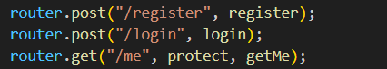
6.7 Course Routes
The course routes include:
Method | Route | Purpose
GET | /api/courses | Fetch all published courses
GET | /api/courses/:id | Fetch one course by ID
POST | /api/courses | Create a new course
POST | /api/courses/:id/enroll | Enroll learner in a course
GET | /api/courses/my-courses | Fetch learner’s enrolled courses

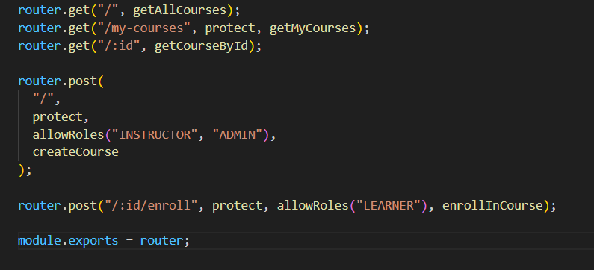
6.8 Lesson Routes
The lesson routes include:
Method | Route | Purpose
GET | /api/lessons/:id | Fetch a lesson
POST | /api/lessons/:id/complete | Mark lesson as completed
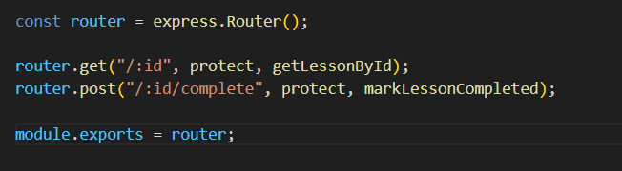
6.9 Quiz Routes
The quiz routes include:
Method | Route | Purpose
GET | /api/quizzes/:id | Fetch quiz questions
POST | /api/quizzes/:id/submit | Submit quiz answers

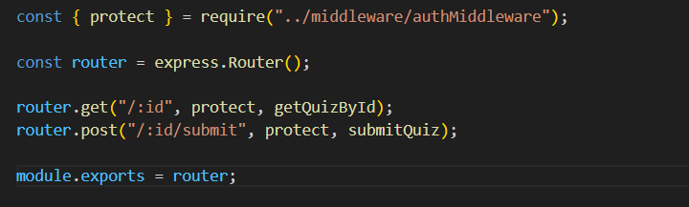
6.10 Dashboard Route
The learner dashboard route is:
GET /api/dashboard/learner
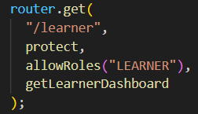
This route returns:
Total enrolled courses
Total lessons
Completed lessons
Progress percentage
Recent quiz results
Enrolled courses
Example response:

{
"success": true,
"dashboard": {
"totalCourses": 1,
"totalLessons": 3,
"completedLessons": 0,
"progressPercentage": 0,
"recentQuizResults": [],
"enrolledCourses": []
}
}
This data is used by the frontend learner dashboard.
7. Connecting Database to Backend
7.1 Environment Variables
The backend database connection was configured using environment variables in the .env file.
Example:
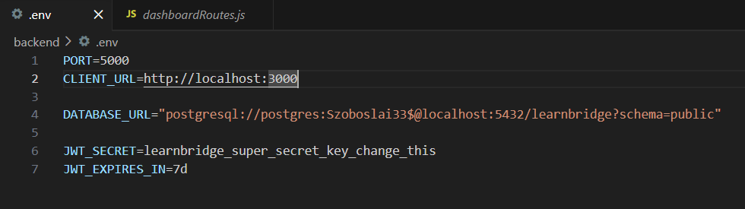
Environment variables are used to keep sensitive information separate from the source code.
7.2 Prisma Client Connections
The backend connects to the database through Prisma Client.
The Prisma connection file is:
backend/src/lib/prisma.js
This file creates a Prisma Client instance that is used by controllers to query the database.
Example:
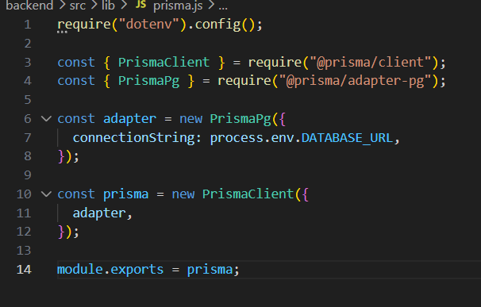
The controllers import this Prisma instance whenever they need to interact with the database.
7.3 Example: Fetching Courses from Database
The course controller uses Prisma to fetch courses.
Example:
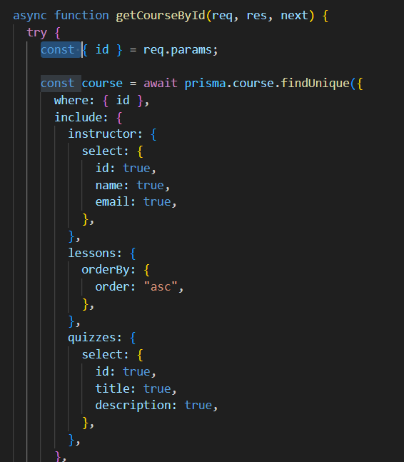
This retrieves courses, their instructors, lessons, and counts for enrollments and lessons.
7.4 Example: Enrolling a Learner
The backend enrolls a learner using the Enrollment table.
Example:
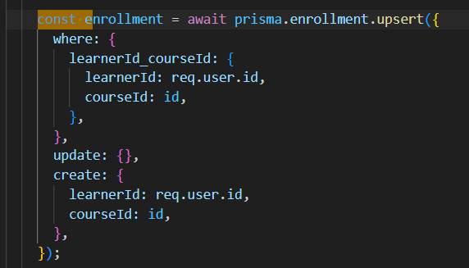
The upsert operation prevents duplicate enrollment because it checks if the learner is already enrolled before creating a new record.
8. Testing
8.1 Backend Health Test
The backend was tested using:

GET http://localhost:5000/api/health
Expected response:
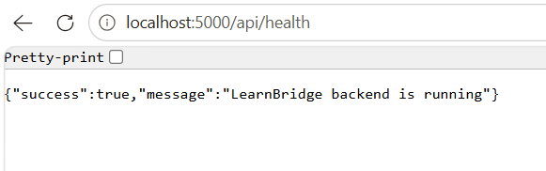
8.2 Login Test
The login route was tested using:
POST http://localhost:5000/api/auth/login
Test body:
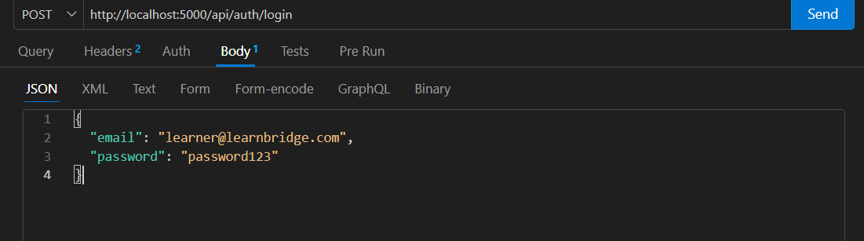
Expected response:
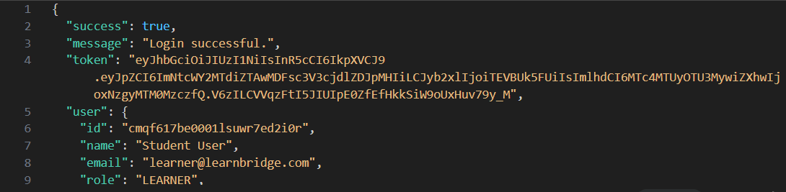
8.3 Courses Test
The courses route was tested using:
GET http://localhost:5000/api/courses
Expected result:
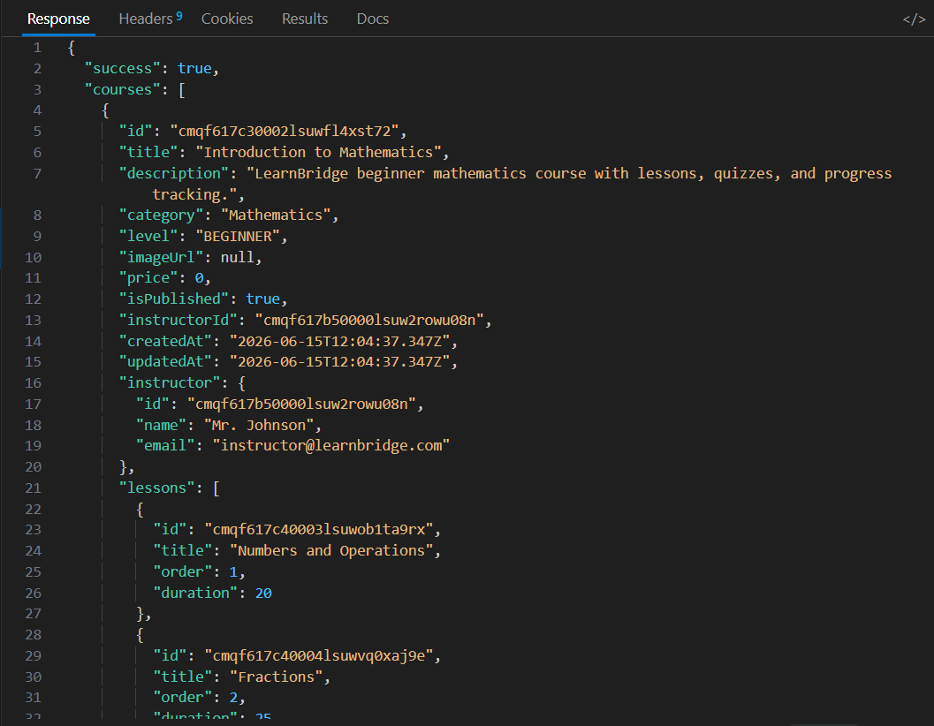
8.4 Dashboard Test
The learner dashboard route was tested using:
GET http://localhost:5000/api/dashboard/learner
The Authorization header was required:
Authorization: Bearer token_here
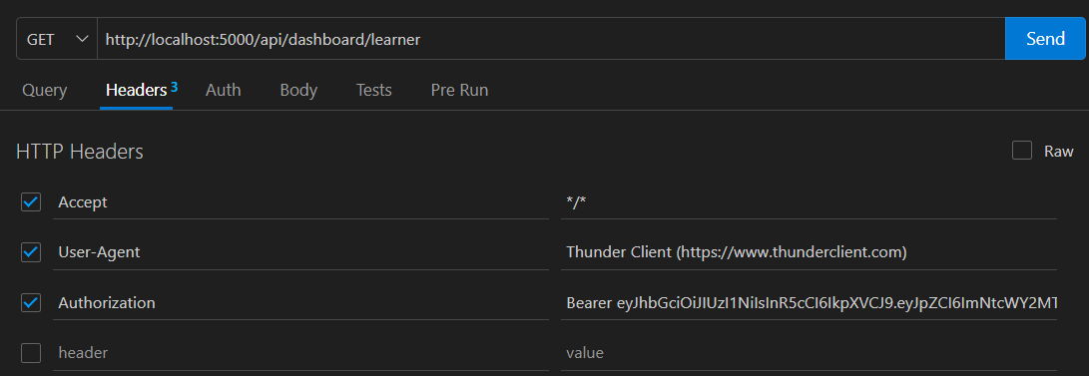
Expected result:
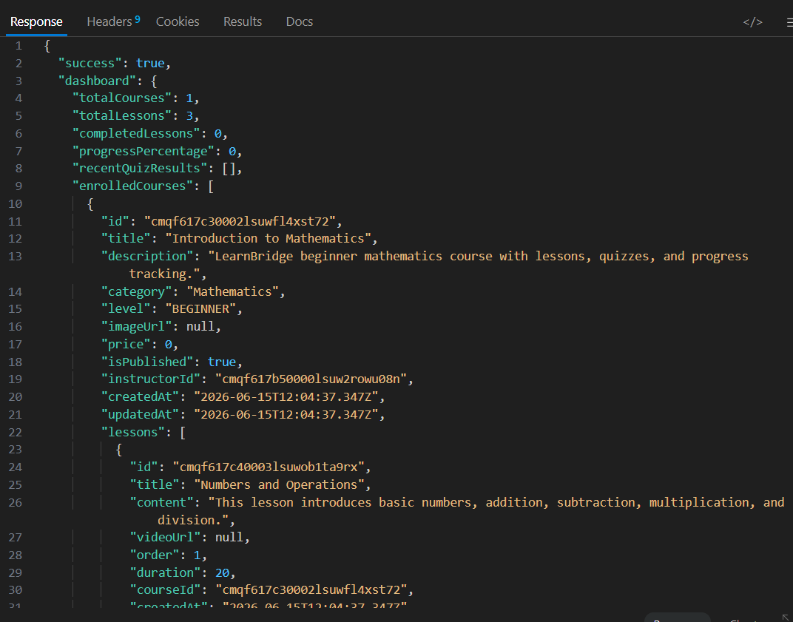
9. Challenges Encountered
Several challenges were encountered during the implementation.

9.1 PostgreSQL Installation
At first, PostgreSQL was not installed, so the database could not be created. This was solved by installing PostgreSQL and creating the learnbridge database.
9.2 Prisma Configuration
Prisma required correct configuration through schema.prisma, .env, and prisma.config.ts. Errors occurred when Prisma could not find the database URL or schema file. These were solved by properly setting the database connection and running Prisma commands from the correct backend directory.
9.3 Authentication Header
Protected backend routes required an Authorization header:
Authorization: Bearer token_here
Without the Bearer prefix, the backend returned an unauthorized error. This was solved by correctly storing and sending the JWT token from the frontend.
10. Conclusion
The database design and implementation for LearnBridge successfully provides a structured way to store and manage system data. The relational database model is suitable for the platform because the system contains many connected entities such as users, courses, lessons, enrollments, progress, quizzes, and quiz results.
PostgreSQL was used as the database, Prisma was used to define and manage the database schema, and Express.js was used to create backend API routes. The backend was successfully connected to the database through Prisma Client.

